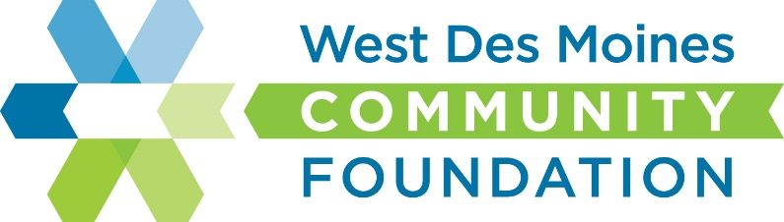

West Des Moines Community Foundation

www.wdmcf.org

Grant Application Overview

Mission Statement
Our mission is to preserve and improve the quality of life in West Des Moines by engaging others in philanthropic support and services.

What We Support
The West Des Moines Community Foundation will provide grants to improve quality of living initiatives in West Des Moines, Iowa. Areas of foundation giving include: arts, culture, humanities, human services, education, and recreation and trails.

Eligibility to Apply for Funding:

Tax exempt, non-profit entities classified by the IRS as 501(c)(3) or a 170 (c)(1) governmental entity

If not 501(c)(3), must have a fiscal sponsor who will be legally & financially responsible

One application per organization

Grant request is $____________

Application Deadline:

Grant applications are due the first calendar day of each quarter: January, April, July, and October for consideration and possible board action during that quarter.

Please forward completed application to: contact@WDMCF.org

Definitions/Explanations

Fiscal Sponsor is an organization that is receiving the money on behalf of the grant applicant and is responsible for disbursing the money for the project and maintaining appropriate documentation. This entity must be a 501(c)(3) or a 170(c)(1) unit of government in order to serve in this capacity. A fiscal sponsorship agreement must accompany the grant application if a fiscal sponsor is being used.*

Organizations must be recognized by the Internal Revenue Service as tax-exempt, nonprofit, public charities under section 501(c)(3) or as a “unit of government” under Section 170(c)(1) to receive grant funding. A 501(c)(3) is a section of the Federal Tax Code, which establishes the criteria for tax-exempt charitable organizations. Section 170(c)(1) refers to agencies that conduct activities to benefit the public at large, like public schools, state universities, public libraries and volunteer fire departments.

501(C)(3) Designation Letter

*Attach to this agreement the Fiscal Sponsor’s 501(c)(3) Tax-Exempt Determination Letter or comparable proof of charitable exemption. (i.e. a letter from a City, confirming their status as a government entity. Contact our Administrative Office with questions, or for examples of a letter from a City.)*

Grant Application Cover Page

Applicant Requesting Funding/Fiscal Sponsor (if the organization is not a 501(c)(3):

Project Title:

Federal tax identification number of Applicant/Fiscal Sponsor (EIN):

Applicant/Fiscal Sponsor Address:

Applicant/Fiscal Sponsor Contact Person & Title:

Applicant/Fiscal Sponsor Contact Person Phone & Email:

Organization conducting project (if different from Applicant/Fiscal Sponsor):

Organization/Project Address (if different):

Organization/Project Contact Person & Title (if different):

Organization/Project Contact Person Phone & Email (if different):

Total Cost of Project: Amount Requested:

Type of Request (check one): Capital Based – The building of or physical improvement of something

Program Based – Operational, activity, general programmatic support

Project Focus Area (check one):

Arts/Culture/Humanities Human Services Education Recreation and Trails Other

Brief Description of Organization:

Brief Description of Project: (If your organization is not a 501(c)(3), please describe the charitable intent of this request.)

Questions of Purpose

1. Describe the need or problem being addressed by this project:

2. Explain how this project will benefit the citizens of West Des Moines:

3. Explain your organization’s ability to carry out and ensure success of this project:

4. Describe the timeline of the project:

5. Have you previously received funding from the West Des Moines Community Foundation?
If so, when?

6.) Would the West Des Moines Community Foundation be recognized for its support? If so, how?

Fiscal Sponsorship Agreement (if applicable)

Date:

Fiscal Sponsor (Legal Applicant):

Fiscal Sponsor Contact Person and Email:

Fiscal Sponsor Full Mailing Address:

Sponsored Organization Conducting Project:

Project Name:

(Legal Applicant/Fiscal Sponsor, hereafter referred to as The Sponsor) has agreed to serve as a fiscal/program sponsor for the (Organization conducting project, hereafter referred to as the Sponsored Org.) as outlined in the attached application and supporting materials. The Board of Directors of The Sponsor has passed a resolution adopting the Sponsored Org.’s project as a program or project consistent with the Sponsor’s purpose and mission. The Sponsored Org.’s financial activities will be accounted for as a program of The Sponsor for IRS auditing and financial reporting purposes.
Since the Sponsored Org. is not recognized by the IRS as a charitable tax-exempt entity, The Sponsor must exercise full control over the Sponsored Org.’s financial administration, management and disbursement of funds resulting from this grant application. The Sponsor has delegated (name of person/s) as responsible for fulfilling these accounting and reporting functions subject to the ultimate authority of the Board of Directors of The Sponsor. The Sponsor is responsible for ensuring completion of timely reports and submission of necessary financial statements to the Community Foundation’s Administrative Office (contact info below). Failure to insure timely reporting on behalf of the Sponsored Org./Sponsor will also result in a loss of good standing.
This agreement will be in effect from the date of a grant award to support the above-named project until the grant funds are expended and the final report has been submitted and accepted.
We agree to the terms stated above in this agreement:

Legal Applicant/ Fiscal Sponsor Representative Signature:

Printed Name: Date:

Sponsored Organization Representative Signature:

Printed Name: Date:

